Set Membership and Inclusion Symbols
# Source: AI Source: Provided by: [Data Path: Persons Table -> ID Column: 1, Name_En Column: Motasem Essam] -> From: [ChatGPT] on [7/7/2026]
Set Membership and Inclusion Symbols are fundamental notations in set theory that describe the relationships between elements and sets, or between sets themselves.

Set Membership and Inclusion Symbols types
# Source: AI Source: Provided by: [Data Path: Persons Table -> ID Column: 1, Name_En Column: Motasem Essam] -> From: [ChatGPT] on [7/7/2026]
Here's a breakdown of these symbols and what they represent:

1. Belonging or Set Membership (∈)
# Source: AI Source: Provided by: [Data Path: Persons Table -> ID Column: 1, Name_En Column: Motasem Essam] -> From: [ChatGPT] on [7/7/2026]
- Definition: Belonging, or set membership, describes the relationship between an element and a set. If an element x is a member of set A, it is written as x∈A.
- Example: If A={1,2,3}, then 1∈A indicates that 1 is an element of set A.

2. Not Belonging or Non-Membership (∉)
# Source: AI Source: Provided by: [Data Path: Persons Table -> ID Column: 1, Name_En Column: Motasem Essam] -> From: [ChatGPT] on [7/7/2026]
- Definition: Not belonging, or non-membership, describes the relationship between an element and a set when the element is not a member of the set. If an element x is not a member of set A, it is written as x∉A.
- Example: If A={1,2,3}, then 4∉A indicates that 4 is not an element of set A.

3. Subset ( ⊆ )
# Source: AI Source: Provided by: [Data Path: Persons Table -> ID Column: 1, Name_En Column: Motasem Essam] -> From: [ChatGPT] on [7/7/2026]
A set A is a subset of set B if every element of A is also an element of B. This is denoted as A⊆B.
- Example: If A={1,2} and B={1,2,3,4}, then A⊆B.
- Example: If B={1,2,3,4} and A={2,3}, then A is a subset of B, written as A⊆B.

4.Not Subset (⊈)
# Source: AI Source: Provided by: [Data Path: Persons Table -> ID Column: 1, Name_En Column: Motasem Essam] -> From: [ChatGPT] on [7/7/2026]
- Definition: A set A is not a subset of a set B if there exists at least one element in A that is not in B. This relation can be expressed using the subset notation with a negation.
Or
A⊈B means there is at least one element x in A such that x∉B.
- Notation: A⊈B
- Example: If A={1,2,3} and B={2,3}, then A⊈B because 1 is in A but not in B.

5. Proper Subset ( ⊂ )
# Source: AI Source: Provided by: [Data Path: Persons Table -> ID Column: 1, Name_En Column: Motasem Essam] -> From: [ChatGPT] on [7/7/2026]
A set A is a proper subset of set B if A is a subset of B and A≠B. This is denoted as A⊂B.
- Example: If A={1,2} and B={1,2,3}, then A⊂B.

6. Not Proper Subset ( ⊄ )
# Source: AI Source: Provided by: [Data Path: Persons Table -> ID Column: 1, Name_En Column: Motasem Essam] -> From: [ChatGPT] on [7/7/2026]
- Definition: A ⊄ B means that either A⊈B (A is not a subset of B) or A=B(A is equal to B).
- Notation: A⊄B
- Example: If A={1,2,3} and B={1,2,3}, then A⊄B because A is equal to B. If A={1,2,3} and B={2,3,4}, then A⊄B because 1 is in A but not in B.

7. Superset ( ⊇)
# Source: AI Source: Provided by: [Data Path: Persons Table -> ID Column: 1, Name_En Column: Motasem Essam] -> From: [ChatGPT] on [7/7/2026]
A set B is a superset of set A if every element of A is also an element of B. This is denoted as B⊇A.
- Example: If B={1,2,3,4} and A={1,2}, then B⊇A.

8. Not Superset (⊉)
# Source: AI Source: Provided by: [Data Path: Persons Table -> ID Column: 1, Name_En Column: Motasem Essam] -> From: [ChatGPT] on [7/7/2026]
- Definition: B⊉A means there is at least one element x in A such that x∉B.
- Notation: B⊉A
- Example: If B={2,3} and A={1,2,3}, then B⊉A because 1 is in A but not in B.

9. Proper Superset ( ⊃)
# Source: AI Source: Provided by: [Data Path: Persons Table -> ID Column: 1, Name_En Column: Motasem Essam] -> From: [ChatGPT] on [7/7/2026]
A set B is a proper superset of set A if B is a superset of A and B≠A. This is denoted as B⊃A.
- Example: If B={1,2,3} and A={1,2}, then B⊃A.

10. Not Proper Superset (⊅)
# Source: AI Source: Provided by: [Data Path: Persons Table -> ID Column: 1, Name_En Column: Motasem Essam] -> From: [ChatGPT] on [7/7/2026]
- Definition: B⊅A means that either B⊉A (B is not a superset of A) or B=A (B is equal to A).
- Notation: B⊅A
- Example: If A={1,2,3} and B={1,2,3}, then B⊅A because B is equal to A. If A={1,2,3} and B={1,2}, then B⊅A because 3 is in A but not in B.

Set Membership and Inclusion Symbols in real life

1. Belonging or Set Membership (∈)
# Source: AI Source: Provided by: [Data Path: Persons Table -> ID Column: 1, Name_En Column: Motasem Essam] -> From: [ChatGPT] on [7/7/2026]
- Grocery Shopping:
  - If G represents the set of items in your shopping cart, and Milk is an item you've picked, then Milk∈G.
  - Similarly, if Eggs are in your cart, Eggs∈G.
- Sports Teams:
  - If T represents the set of players in a football team, and John is a player, then John∈T.
  - If Sarah is another player, Sarah∈T.
- Classroom:
  - If C represents the set of students in a classroom, and Ahmed is a student in that class, then Ahmed∈C.
  - If Mariam is another student, Mariam∈C.

2. Not Belonging or Non-Membership (∉)
# Source: AI Source: Provided by: [Data Path: Persons Table -> ID Column: 1, Name_En Column: Motasem Essam] -> From: [ChatGPT] on [7/7/2026]
- Grocery Shopping:
  - If G represents the set of items in your shopping cart, and Bread is not in your cart, then Bread∉G.
  - If Butter is also not in your cart, Butter∉G.
- Sports Teams:
  - If T represents the set of players in a football team, and Mike is not a player on that team, then Mike∉T.
  - If Linda is not on the team either, Linda∉T.
- Classroom:
  - If C represents the set of students in a classroom, and Ali is not a student in that class, then Ali∉C.
  - If Fatima is not in that class either, Fatima∉C.

3. Subset ( ⊆ )
# Source: AI Source: Provided by: [Data Path: Persons Table -> ID Column: 1, Name_En Column: Motasem Essam] -> From: [ChatGPT] on [7/7/2026]
- Library:
  - If B represents the set of all books in the library and F represents the set of fiction books in the library, then F⊆B because all fiction books are part of the library's collection.
  - If R represents the set of reference books in the library, then R⊆B because all reference books are part of the library's collection.
- Company Departments:
  - If E represents the set of all employees in a company and IT represents the set of employees in the IT department, then IT⊆E because all IT employees are also employees of the company.
  - If HR represents the set of employees in the HR department, then HR⊆E because all HR employees are also employees of the company.
- Students in Courses:
  - If S represents the set of all students in a school and M represents the set of students enrolled in a mathematics course, then M⊆S because all mathematics students are part of the student body.
  - If P represents the set of students enrolled in a physics course, then P⊆S because all physics students are part of the student body.

4.Not Subset (⊈)
# Source: AI Source: Provided by: [Data Path: Persons Table -> ID Column: 1, Name_En Column: Motasem Essam] -> From: [ChatGPT] on [7/7/2026]
- Library:
  - If B represents the set of all books in the library and C represents the set of cookbooks in a nearby bookstore, then C⊈B because not all cookbooks are part of the library's collection.
  - If N represents the set of novels in a different library, then N⊈B because not all novels from the other library are part of the current library's collection.
- Company Departments:
  - If E represents the set of all employees in a company and D represents the set of employees in a different company, then D⊈E because not all employees from the other company are part of the current company.
  - If T represents the set of temporary contractors who are not employees, then T⊈E because they are not part of the company employee set.
- Students in Courses:
  - If S represents the set of all students in a school and A represents the set of students in an after-school art club, then A⊈S because not all art club members are students of the school.
  - If G represents the set of students from a different school, then G⊈S because not all students from the other school are part of the current school's student body.

5. Proper Subset ( ⊂ )
# Source: AI Source: Provided by: [Data Path: Persons Table -> ID Column: 1, Name_En Column: Motasem Essam] -> From: [ChatGPT] on [7/7/2026]
1. Library:
- If B represents the set of all books in the library and F represents the set of fiction books in the library, then F⊂B because all fiction books are part of the library's collection, and the library has books that are not fiction.
- If C represents the set of cookbooks in the library, then C⊂B because all cookbooks are part of the library's collection, and the library has books that are not cookbooks.
2. Company Departments:
- If E represents the set of all employees in a company and IT represents the set of employees in the IT department, then IT⊂E because all IT employees are part of the company, and the company has employees in other departments.
- If HR represents the set of employees in the HR department, then HR⊂E because all HR employees are part of the company, and the company has employees in other departments.
3. Students in Courses:
- If S represents the set of all students in a school and M represents the set of students enrolled in a mathematics course, then M⊂S because all mathematics students are part of the school, and the school has students in other courses.
- If P represents the set of students enrolled in a physics course, then P⊂S because all physics students are part of the school, and the school has students in other courses.

6. Not Proper Subset ( ⊄ )
# Source: AI Source: Provided by: [Data Path: Persons Table -> ID Column: 1, Name_En Column: Motasem Essam] -> From: [ChatGPT] on [7/7/2026]
- Library:
  - If B represents the set of all books in the library and G represents the set of genres in the library, then G⊄B because genres are not individual books.
  - If A represents the set of audiobooks available in a different library, then A⊄B because audiobooks are not part of the current library's collection.
- Company Departments:
  - If E represents the set of all employees in a company and V represents the set of visitors, then V⊄E because visitors are not employees of the company.
  - If S represents the set of suppliers, then S⊄E because suppliers are not part of the company's employees.
- Students in Courses:
  - If S represents the set of all students in a school and T represents the set of teachers, then T⊄S because teachers are not students.
  - If P represents the set of parents, then P⊄S because parents are not part of the school's students.

7. Superset ( ⊇)
# Source: AI Source: Provided by: [Data Path: Persons Table -> ID Column: 1, Name_En Column: Motasem Essam] -> From: [ChatGPT] on [7/7/2026]
- Library:
  - If L represents the set of all books in a city library system and B represents the set of books in a single branch, then L⊇B because the city library system includes all books in the individual branch and possibly more.
  - If L represents the set of all books in your home library and M represents the set of mystery novels in your home library, then L⊇M because your home library includes all mystery novels and possibly more books of other genres.
- Company Departments:
  - If E represents the set of all employees in a company and T represents the set of employees in the tech department, then E⊇T because the company includes all employees in the tech department and possibly employees in other departments.
  - If E represents the set of all employees in a corporation and I represents the set of interns, then E⊇I because the corporation includes all interns and possibly permanent employees as well.
- Classroom:
  - If S represents the set of all students in a school and G represents the set of students in grade 10, then S⊇G because the school includes all students in grade 10 and possibly students from other grades.
  - If T represents the set of all students in a school's tech club and P represents the set of students who are programmers in the tech club, then T⊇P because the tech club includes all programmers and possibly members with other roles.

8. Not Superset (⊉)
# Source: AI Source: Provided by: [Data Path: Persons Table -> ID Column: 1, Name_En Column: Motasem Essam] -> From: [ChatGPT] on [7/7/2026]
- Library:
  - If C represents the set of cookbooks in a bookstore and L represents the set of all books in the city library system, then L⊉C because not all cookbooks in the bookstore are part of the city library system.
  - If E represents the set of e-books in an online store and B represents the set of printed books in a library, then B⊉E because printed books in the library do not include all e-books from the online store.
- Company Departments:
  - If E represents the set of all employees in a company and V represents the set of visitors, then E⊉V because the company does not include all visitors.
  - If E represents the set of all employees in a corporation and C represents the set of contractors, then E⊉C because the corporation does not include all contractors.
- Classroom:
  - If S represents the set of all students in a school and A represents the set of athletes in a different school, then S⊉A because the students in one school do not include the athletes from a different school.
  - If C represents the set of students in a choir and B represents the set of students in a different school's band, then C⊉B because the choir students do not include the band students from a different school.

9. Proper Superset ( ⊃)
# Source: AI Source: Provided by: [Data Path: Persons Table -> ID Column: 1, Name_En Column: Motasem Essam] -> From: [ChatGPT] on [7/7/2026]
- Library:
  - If L represents the set of all books in your home library and N represents the set of novels in your home library, then L⊃N because your home library includes all novels and also other types of books.
  - If D represents the set of all documents in your office and R represents the set of reports, then D⊃R because the office has all reports and also other types of documents.
- Company Departments:
  - If E represents the set of all employees in a corporation and T represents the set of technical staff, then E⊃T because the corporation includes all technical staff and also employees from other departments.
  - If M represents the set of all managers in a company and P represents the set of project managers, then M⊃P because all project managers are part of the managers, but there are other types of managers as well.
- Classroom:
  - If S represents the set of all students in a school and B represents the set of students who are also members of the school's band, then S⊃B because all band members are students, but there are other students who are not in the band.
  - If G represents the set of all students in grade 10 and A represents the set of students in the advanced placement (AP) program in grade 10, then G⊃A because all AP students are in grade 10, but there are other grade 10 students who are not in the AP program.

10. Not Proper Superset (⊅)
# Source: AI Source: Provided by: [Data Path: Persons Table -> ID Column: 1, Name_En Column: Motasem Essam] -> From: [ChatGPT] on [7/7/2026]
- Library:
  - If L represents the set of all books in a public library and C represents the set of comic books in a friend's collection, then L⊅C because the public library does not include all comic books from your friend's collection.
  - If M represents the set of all magazines in a bookstore and A represents the set of art books in an art gallery, then M⊅A because magazines in the bookstore do not include all art books from the gallery.
- Company Departments:
  - If E represents the set of all employees in a company and C represents the set of contractors, then E⊅C because the company's employees do not include all contractors.
  - If D represents the set of design team members and F represents the set of freelance designers, then D⊅F because the design team does not include all freelance designers.
- Classroom:
  - If S represents the set of all students in a school and O represents the set of students in an online course, then S⊅O because not all students in the online course are part of the school.
  - If T represents the set of students in the tech club and M represents the set of mentors from a different organization, then T⊅M because the tech club does not include all mentors from the other organization.

Academic Source: First primary - First term - Unit 1: Unit Two: Sets

Lesson Three: Belonging of an element to a set
# Source: Academic source: Provided by: [Data Path: Persons Table -> ID Column: 1, Name_En Column: Motasem Essam] -> From: [Data Path: Sources Table -> ID Column: 351, Content Title Column: Math - Fifth Primary - First Semester] -> at: [Document, page: 54:55] on [7/7/2026]
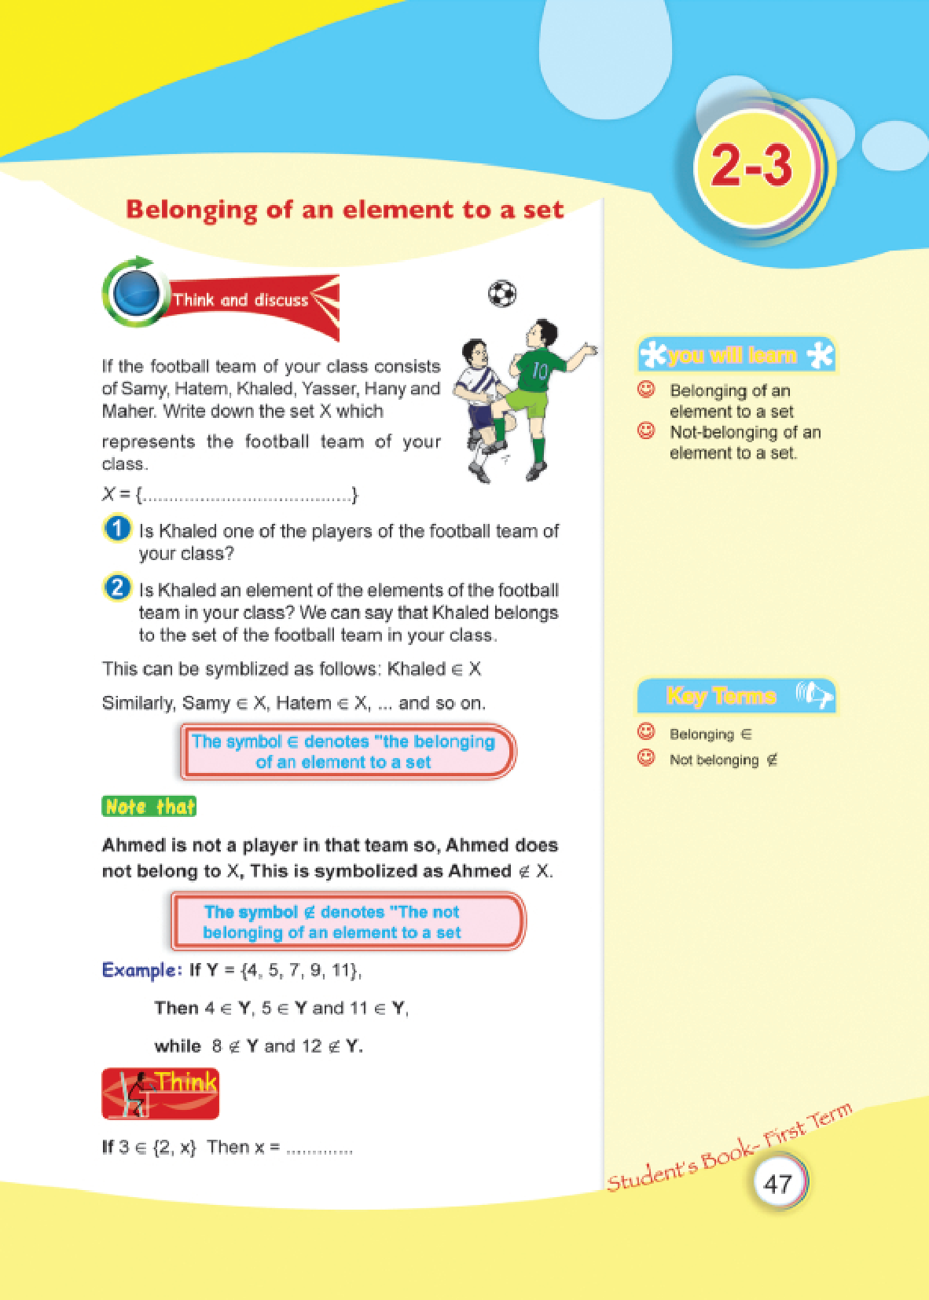

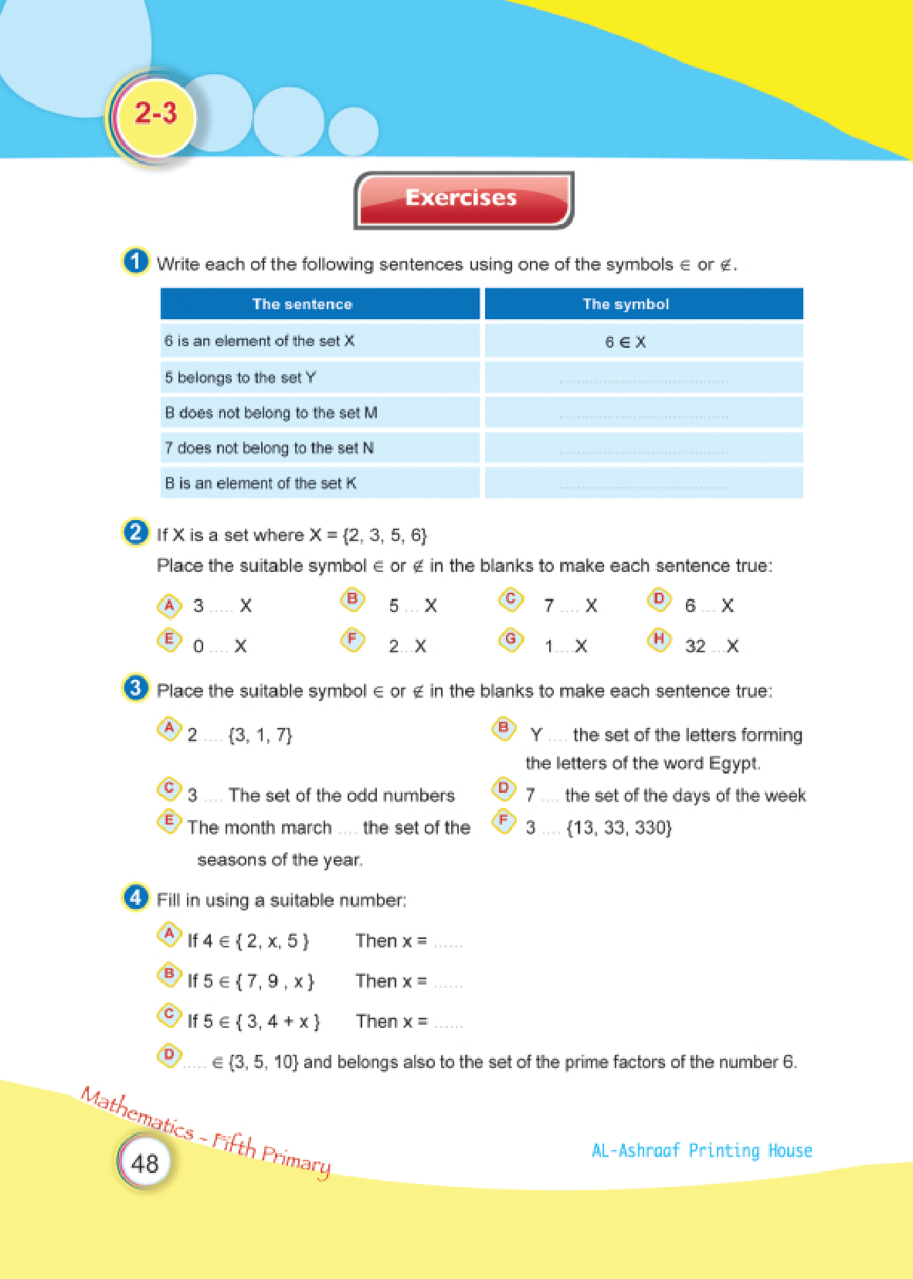

Lesson Six: Inclusion and subsets
# Source: Academic source: Provided by: [Data Path: Persons Table -> ID Column: 1, Name_En Column: Motasem Essam] -> From: [Data Path: Sources Table -> ID Column: 351, Content Title Column: Math - Fifth Primary - First Semester] -> at: [Document, page: 60:62] on [7/7/2026]


